Jin Ou

Dec. 4, 2019

Python

Assignment 8

**Introduction:**

The purpose of this assignment is to work with classes. Three classes are created, Product, FileProcessor, and IO(input/output). The script is used to ask user for add product and their price to a list. And save that to a file.

**Method:**

Three classes were created.

The first class is the product main class, it’s used to create variable and set restrictions. The product name and product price variables are created here in contains a getter property. The setter property is added to create restrictions to these variables. Methods are not needed in this class since nothing is to be done with these variables.

The next class created is the fileprocessor, it’s used to contain the static methods used to process the txt file. In this case, loading the data and saving the data. No fields or constructors are created since it’s only for operations. I originally intended to use a list of dictionary to store the data however I encountered an error I couldn’t go around 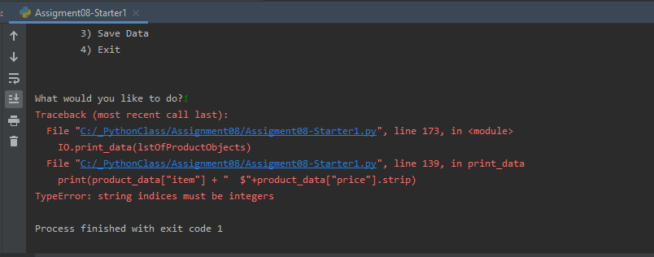

This is the code correlated to the error.

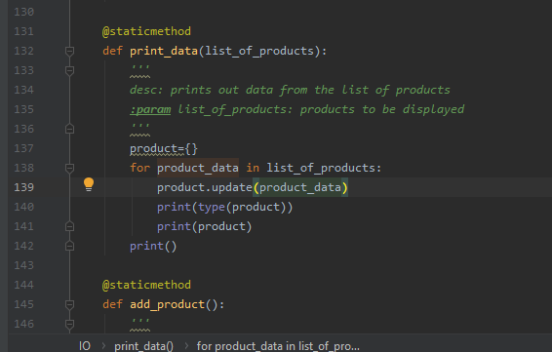

So I used lists instead. And nothing similar to that pop up. It’s some issue related to dictionary in lists.

Next class is IO(input/output), this class is consist of 3 static methods, display menu, display data, and add product to the data list. All of which are similar to the previous assignments so I copied most of the codes from the previous assignments, with a little bit of editing to adjust to this assignment.

However there’s still an issue with the current code. The first time the code is ran, it will run fine, and the new data will look normal in the txt file like following.

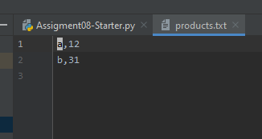

But after a couple times adding data the txt file will start spacing out as show below

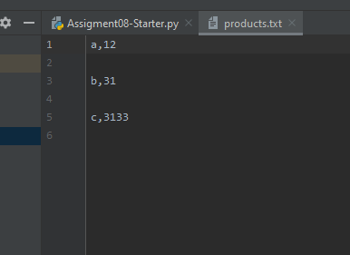

And error will pop up in the code

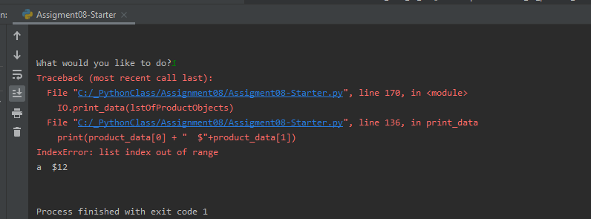

**Summary:**

The script utilizes classes to simplify the codes in the main body. The script functions as processor of of the products.txt. It reads and edits the txt file in command. It can add entries to the txt file but not removing.